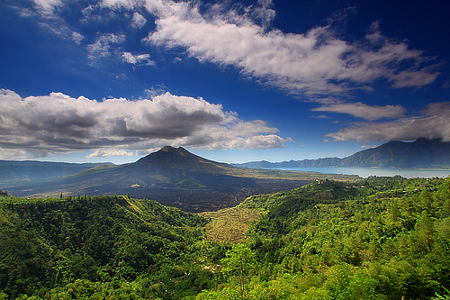

**GEOG 101: Introduction to Environmental Geography**

**Keywords**

General Education (Nature and Technology)

Natural Environmental Systems

## **Prerequisites**

## None

**What will students learn in this class?**

This course provides a broad survey of the physical environment including topics such as vegetation and plant ecology, rocks and weathering, landforms, surficial processes, and soils. An emphasis is placed on explaining and appreciating the physical landscape and environment. At the end of this course, students will be able to explain spatial patterns in earth's physical environment, understand the Earth's physical processes that are responsible for shaping Earth's surface over time, utilize and interpret various types of geographic data, imagery and maps and understand human impacts on the environment and how environmental conditions affect human activities.

**Questions we might ask in class...**

* What causes volcanoes, earthquakes and tsunamis?
* Why do plant and animal communities look different in different regions of the world?
* How did the glaciers form the Great Lakes?
* How will climate change impact our natural environment?

## **Learning Outcomes**

## Describe different natural processes operating on Earth.

## Describe the interactions among these process and explain how they shape the natural environment we see today.

## Explain the impact of human activities on natural environmental systems.

**What students are saying about this class...**

* “I loved every topic we learned about! The instructor kept it interesting.”
* “The professor has made me realize that I have an interest in the Earth’s geography.”

## **Course Format**

## Mixture of lecture, online and in class quizzes, discussion, and assigned readings. Class sizes typically range from 50-150 students.